Day of Action
What you need to know!!!
- Sign up for Day of Action between May 22- June 14
- On day of event wear appropriate clothing according to the project you will be doing
- Must wear closed toe shoes
- Wear sunscreen and bug spray(bring extra with you to apply again if needed)
- If able to bring tools or equipment please make sure they are labelled
- Limited bathrooms near projects so plan accordingly
- A snack, gloves and water will be provided
- Meet at staging area at 1:00pm at All American Pharmaceuticals 2376 Main Street
- Know what zone color you are assigned to
- Find your team leader in parking lot by your zone color
- Sign in and get a wristband from your team leader
- There is limited parking so we are asking teams to carpool to their project
- Some projects you may need to walk a good distance to get too.
- Tag any photos taken to: #UnitedWayofYellowstone #DayofAction #Community Impact #Volunteering
- Have fun!!! Enjoy being outside and take in the beautiful scenes and listen for animals
- Keep your wristband on if attending after party at Tiny’s Tavern from 5-7

Merlin App- This app offers four fun ways to identify birds. Answer a few simple questions, upload a photo, record a singing bird, or explore birds in a region. Link for Merlin App:
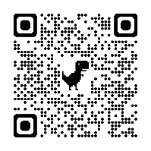
Android phones:

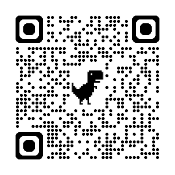
Apple Phones:

- Seek App- take a picture of a plant or animal and it will identify what it is and learn about the organisms all around you. QR code for Seek App:
Android Phones:
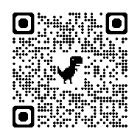

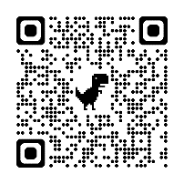
Apple Phones:

